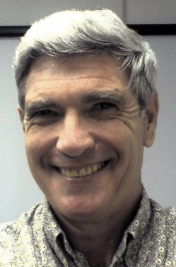
Bruce L. Ullman is Jefferson Lab’s Training and Performance Consultant. He is the only person who has ever held this position, having been hired in Jan 1998. Bruce created the Lab’s current training program, wrote the training policies, conceived the Lab’s skill-based training tracking system, created and published many of the Lab’s current courses (both online and traditional), and teaches several of them. He is a certified Myers Briggs Type Inventory (MBTI) adminstrator. He was also the Lab’s initial expert on Diversity and Inclusion and, in that capacity, trained the D&I Council, created and conducted two climate surveys, and served as a judge of the D&I programs of other organizations.
Prior to his JLab career, Bruce spent 25 years in the US Air Force as a Personnel Officer, Educator, and Management Analyst, retiring as a Colonel. He earned a BA in History from Rutgers University, an MA in College Personnel Administration from New York University, and a Masters in Public Administration from Auburn University. He is also an honor graduate of USAF Squadron Officers School, Air Command and Staff College, and Air War College.
Bruce and his wife of 51 years live in Williamsburg. They have one daughter and two grandchildren.

